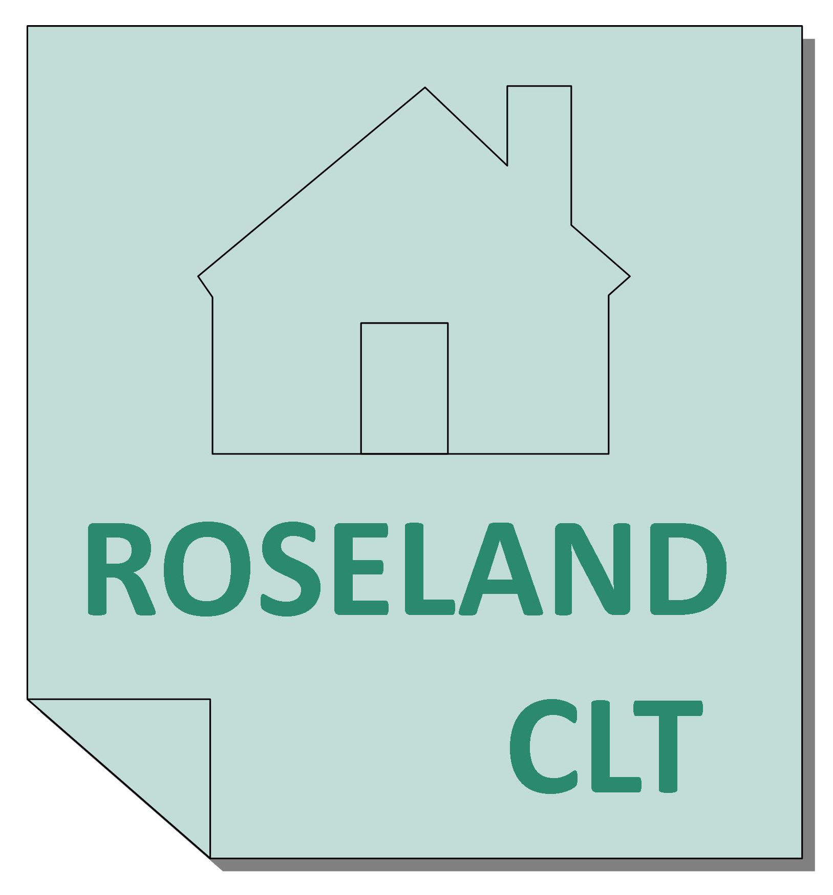
The Roseland CLT Limited
Registered Office: Harriets, Treworthal, Ruan High Lanes, Truro, Cornwall TR2 5LR

Membership Policy
The Roseland CLT Limited is a charitable Community Land Trust. The Trust was formed in 2007 for the benefit of the Community of the Parish of St Just in Roseland and extended (in 2015) to include the Parishes of Gerrans, Philleigh, Ruan Lanihorne and Veryan to carry out a number of Objects for the Community including:
- the provision of houses and any associated amenities for persons in necessitous circumstances upon terms appropriate to their means;
- the maintenance, improvement or provision of public amenities;
- the advancement of education and/or vocational training amongst the residents of the area of benefit and the creation of training and employment opportunities by the provision of workspace, buildings and/or land for use on favourable terms.

The Charity is committed to achieving a wide membership in order to enhance its accountability to the local community. It is controlled by a Board of Trustees drawn from and elected by the members.

Who can be a member?
Membership is open to any individual or organisation interested in promoting the Objects and who:
- applies to the Charity in the form required by the Trustees;
- is approved by the Trustees;
- pays a subscription of £1 as required by the Trustees; and
- signs the Register of members or consents in writing to become a member either personally or (in the case of a member organisation) through an authorised representative.

How much does it cost?
Membership will cost £1 per member. Please note that every member must promise, if the Charity is dissolved while he, she remains a member or within 12 months afterwards, to pay up to £1 towards the costs of dissolution and the liabilities incurred by the Charity while the contributor was a member.

How do I become a member?
Any applications for membership should be made in writing to our registered office using the attached form and should be accompanied by a signed acceptance to undertake the obligations of a member plus the one pound required for the subscription. Every application will be considered by the Board of Trustees at the next available meeting. If the application is approved you will be notified and your details will be entered in the register of members. If your application is not approved we will let you know and return your money.

What happens when I become a member?
You are entitled to stand for election to our Board of Trustees and also to vote in those elections. You will receive invitations to all our official functions including the Annual General Meeting. We would also hope that you have your say about how the Charity is run and also promote its work whenever and wherever you can.

What is the composition of the Board of Trustees?
The Board of Trustees consists of up to twelve Trustees. A variety of interest and stakeholder groups from the area of benefit will be represented on the Board of Trustees, including one representative of Cornwall Council and at least one from each of St Just in Roseland, Gerrans, Philleigh, Ruan Lanihorne and Veryan Parishes.

Further information can be obtained from our Secretary using the contact details given on the CLT website (www.roselandclt.org).

The Roseland CLT Limited
Registered Office: Harriets, Treworthal, Ruan High Lanes, Truro, Cornwall TR2 5LR

Membership Application Form
Please complete this form and return it to the Company Secretary at the Registered Office.

1. Applicant Details

Name:
Address:

Email address:

Phone Number:

- Declaration

I confirm that I will promote the Objects of The Roseland CLT Limited within the Parishes of St Just in Roseland, Gerrans, Philleigh, Ruan Lanihorne and Veryan as follows:-
- The provision of houses and any associated amenities for persons in necessitous circumstances upon terms appropriate to their means.
- The maintenance, improvement or provision of public amenities.
- The advancement of education and/or vocational training amongst the residents of the area of benefit and the creation of training and employment opportunities by the provision of workspace, buildings and/or land for use on favourable terms.

I also promise that if the Charity is dissolved while I remain a member, or within 12 months afterwards, I will pay up to £1 towards the costs of dissolution and the liabilities incurred by the Charity while I was a member. I enclose the £1 membership fee (refundable if membership is not granted).

Signed Date

For office use only:
Date £1 Received: ..../..../....
Reference allocated in Agenda:
Date Approved by Board: ..../..../....

